**iOS Development**

**Assignment-1 Part-2**

**Submitted by : Submitted to:**

**Srikanth Babu Mr: Manhar Kapoor**

**Student ID: Date:16-07-2021**

**A00113354**

**Xcode**: Xcode is the Apple’s Integrated Development Environment (IDE) for mac OS released in 2003, used to develop software for macOS, i0S, ipdOS,watchOS. The latest version is 12.5.1 released on june 21, 2021.

**How to install Xcode:**

If the user is using macbook then he will be able to download Xcode from the app store Launch it and use it.

If the user wants to use Xcode on the windows PC then he needs to go through few steps. The below are the steps for downloading and installing Xcode on a windows PC.

1. **Download and install VirtualBox for windows**

Downloading and installing Virtualbox enables you to run multiple virtual machines including Xcode.

Visit <https://www.virtualbox.org/wiki/Downloads> link and click download. You should be using 64bit windows and 4gb of RAM to complete this installation.

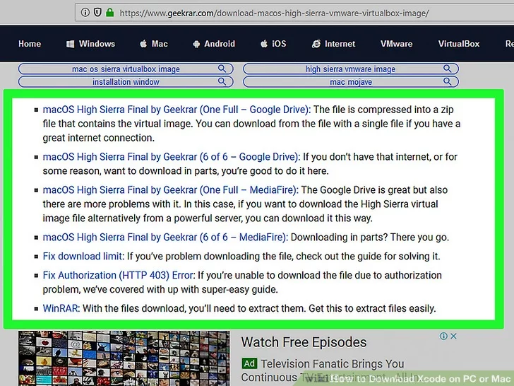

1. Download macOS High Sierra Final
2. The above downloaded file will be a Zip file , you need to un zip the file and you will get to see a folder with .txt or .vmdk file.
3. Search for **Virtual box** in the below search bar and click on it to open.

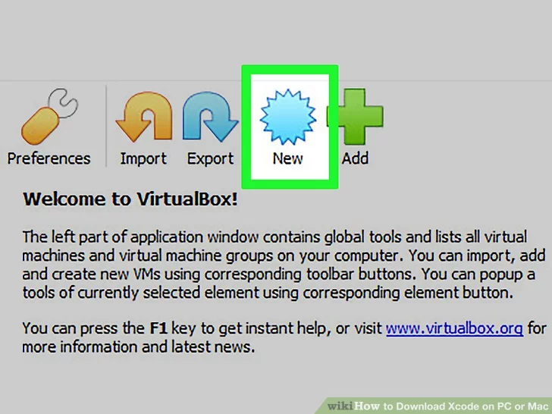

1. Click on the new which is on the top left corner, then there pops up a new create virtual machine window.

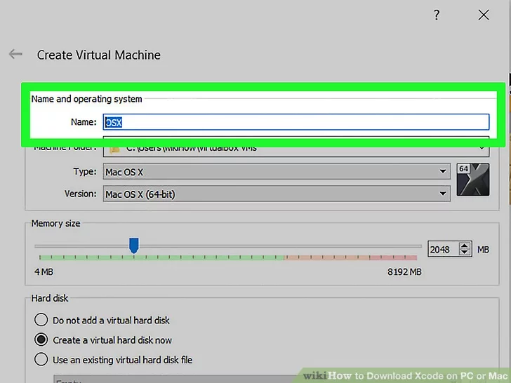

1. Type OSX in the name field. Select ‘Mac OS X’ from the Type drop down menu and then select ‘64bit version’ under version dropdown menu.
2. Click next opti0n on the bottom of the window.
3. Drag and adjust the mem0ry size between 3 to 6gb and click next.
4. Create a hard disk, here is how to do it

* Select “Use an existing virtual hard disc drive” from the drop-down menu.
* Select the browse option.
* Go to the.vmdk file for High Sierra that you extracted earlier.
* Click Create after selecting the file.

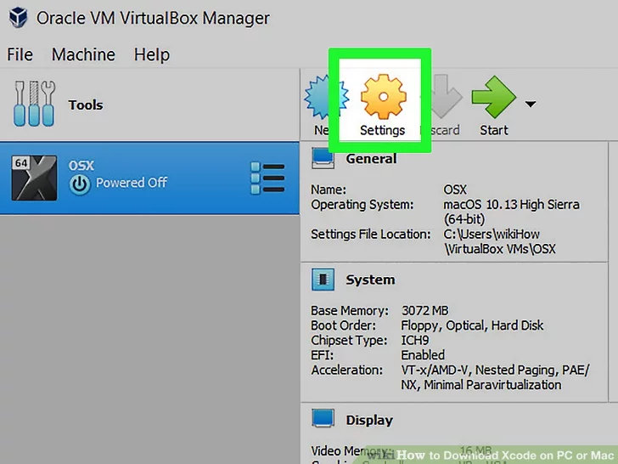

1. Click settings on the top left corner of the window and then edit your virtual machine.

Make the changes in your system as shown in the below

* + Select system in the left column
  + Select ICH9 from the "Chipset" option on the motherboard tab and check the box next to Enable EFI.
  + Select 2 as the number of processors on the Processor tab, then adjust the “Execution cap” slider to 70%.
  + select Display.
  + Select 128 MB as the Video Memory opti0n on the Screen tab.
  + To save all the above chanes click ok.

1. After following all the above stps close the VirtualBox window.
2. Open CMD and run it.
3. Run the CMDin the following order and press enter.

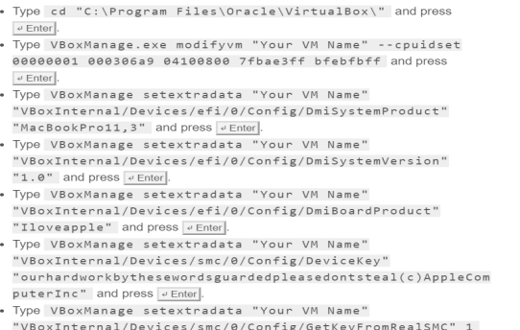

1. Open the VirtualBox again and click start icon on the top left corner of the screen.

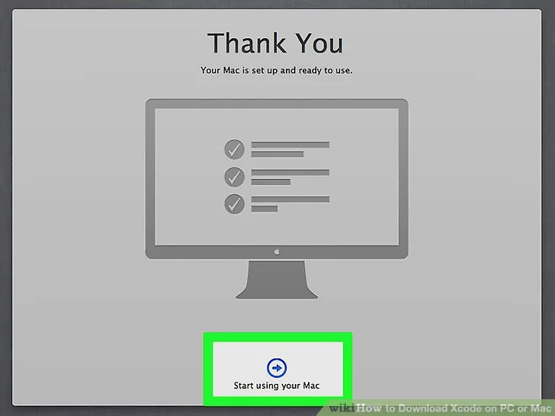

1. Now set up your virtual Mac. Follow the instructions on the screen to set up the high sierra as a new computer. Once you done with all the set up log in with the apple ID.
2. Once you login a new Home screen will open.

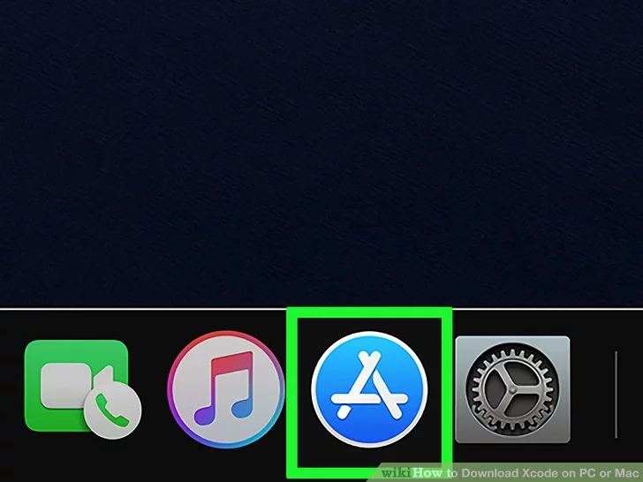

1. Now open App store and search for Xcode and then click on install button.

After installing is done open the xcode app.

1. After opening the app, It will asks you to agree the terms and conditions.

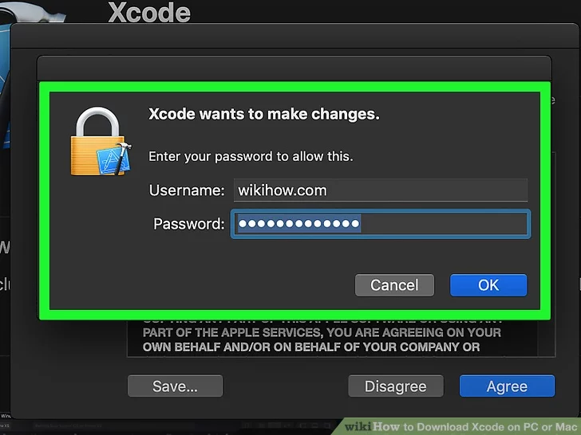

1. Now enter your apple ID and Password to use Xcode.

**X code and its capabilities:** X code has announced some great feature this year. The following are the few X code features.

* **SwiftUI:** This is a big announcement announced by apple this year. Xcode gives us real experience by providing user inteface screnn side by side while editing file. It requires a declarative syntax while using and animations are easy in it.
* **Minimap:** Minimap is a super cool feature in Xcode. It is on left of our screen and helps us to jump to any specific line of the code.
* **Rich Documentation:** The documentation looks better with clarity in Xcode.
* **Swift Package Manager:** X code all0ws us to use its own package manager. We can select this by going to files.
* **Inline Diff:** As demonstrated below, Xcode 11 has an enhanced UI for showing changes in each line of code based on version control.
* **Transform ipad Apps to Mac:** It's simple to port and run iPad apps on a Mac with the new Xcode 11. You can do this by going to the Project Navigator and checking the appropriate box.

**Xcode Interface**: In Interface Builder, you design your app's user interface. Select a user interface file in the project navigator, and the contents of the file open in Interface Builder in the workspace window's editor area. The filename extension for a user interface file is.storyboard or.xib. A single view controller or menu bar is commonly specified in a xib file**.**

A storyboard is a visual representation of a group of view controllers and the transitions between them. A storyboard, unlike a xib, can contain a large number of view controllers as well as the transitions between them. When you use Xcode's built-in templates to build new projects, it includes default user interface files.

**References:**

[**https://www.wikihow.com/Download-Xcode-on-PC-or-Mac#/Image:Download-Xcode-on-PC-or-Mac-Step-6.jpg**](https://www.wikihow.com/Download-Xcode-on-PC-or-Mac#/Image:Download-Xcode-on-PC-or-Mac-Step-6.jpg)

[**https://www.journaldev.com/30976/xcode-11-features**](https://www.journaldev.com/30976/xcode-11-features)